Custom IPSEC always on VPN for Domain

The aim of this setup is to have IPSEC password less VPN that dials whenever not on a domain network. It uses powershell as only enterprise windows on GPO or Intune computers support always on VPN out the box

Step 1) Set external name
Before adding any roles to the server make sure to give it an externally routable external name
Open advance system settings, change name and more:
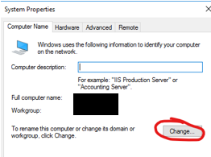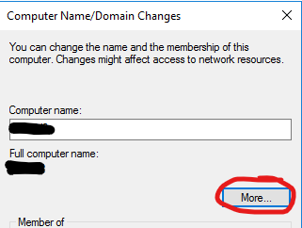
Set the domain name to the external name and untick the auto change
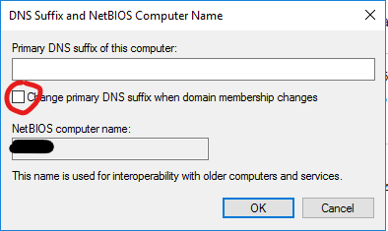
This mean any certificates generated will have external host name and the VPN endpoint will match the external name given to clients. You cannot change this once CA is installed.

2) Install CA
Install the certificate services and make the machine a root certificate authority for the domain.
Then create GPO to enable auto enrolled certificates
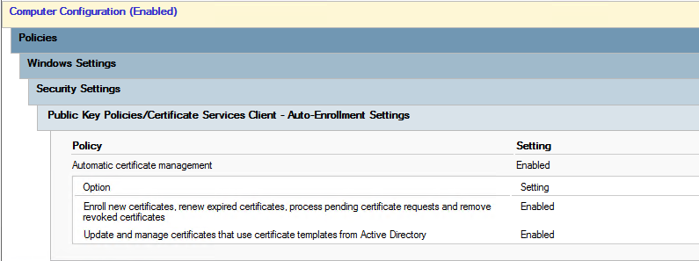
Then load up the certificate authority management tool, right click on templates and manage
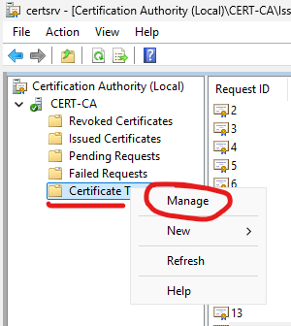
Then find the Workstation template and right click and duplicate
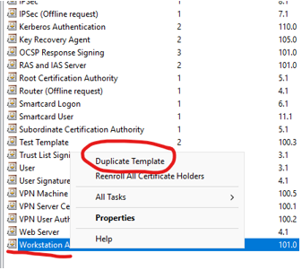
Setup the template for IPSEC enrolment
Give the template a name and set the level to highest.
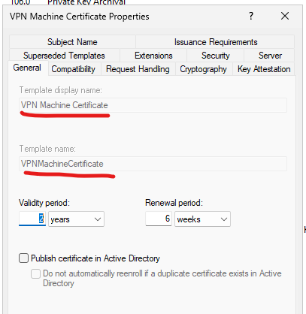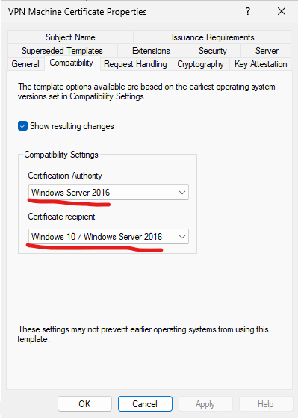
Set Private key exportable and set permissions (this is the bit that lets the computers enrol themselves)
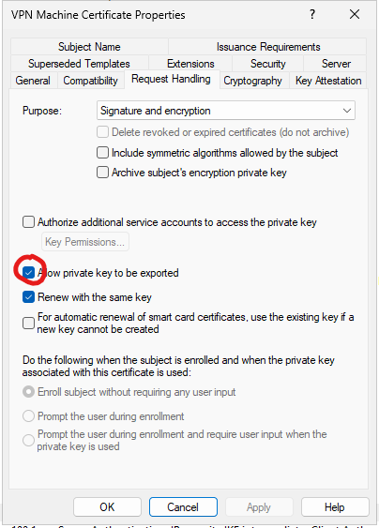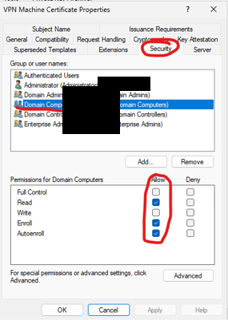

Make sure the cert has the IPSEC component
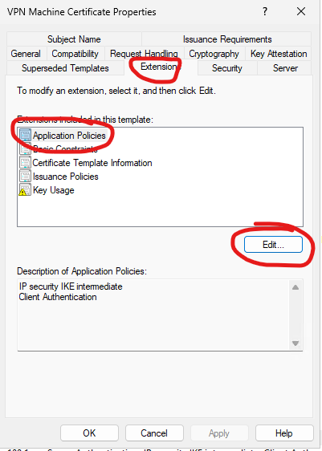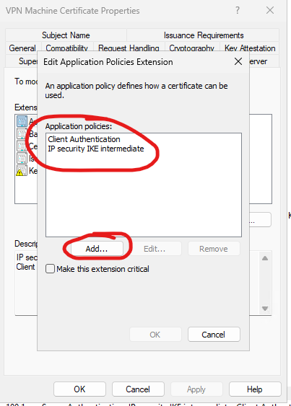
Everything else should be default
Now do the same for server certificate by duplicating the RAS and IAS template and adding in the IPSEC application policy like above
In the permissions set the enrolment to just the machine that will be the RAS endpoint
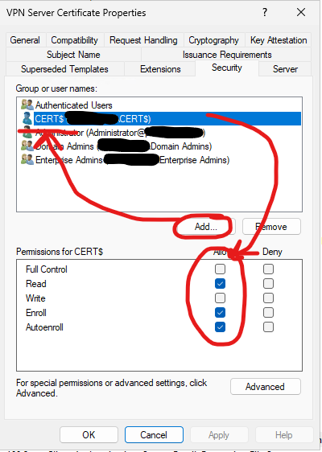
Check certificates are starting to be issues (when gpo updates)
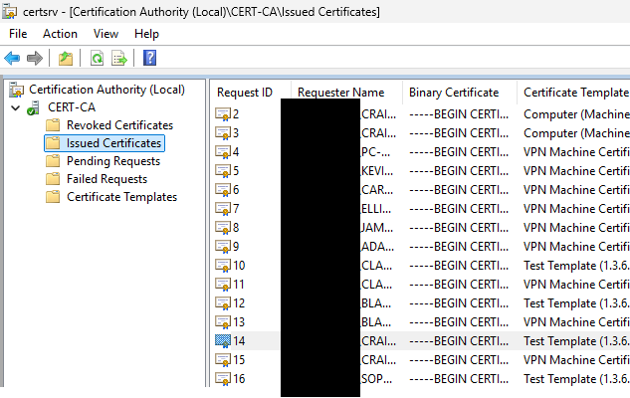
3) Setup VPN RAS server
This setup is all standard except you need to enable IPSEC encryption and set then endpoint to use the certificate generated for the server
Right click the server and go to properties
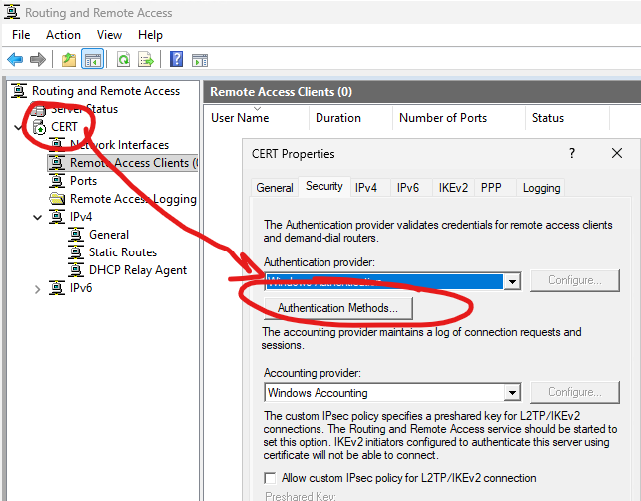
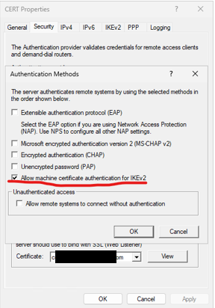
Enable the IPSEC auth here
If wanted, remove all but IPSEC connection by right clicking the ports and go to properties and reduce all but IKE to 0
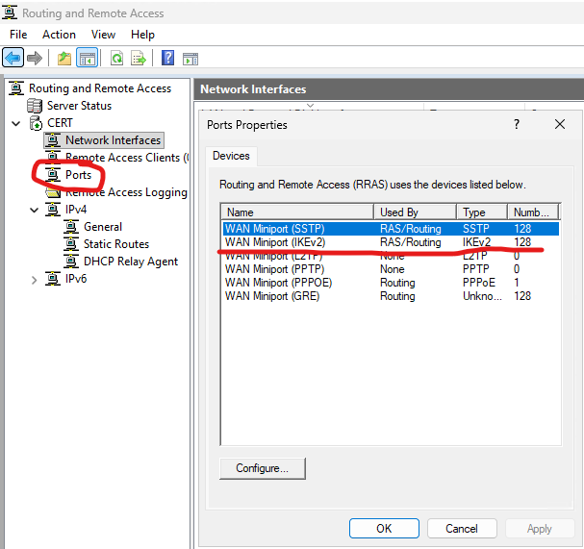
4) Deploy with GPO
Now we need to deploy the script that manages the whole process through GPO, this GPO copies the two script files (they need to be on the machine as they will not be on the domain when the machine starts up) and then sets the batch file to run on startup (uses batch to get around powershell signature policy)
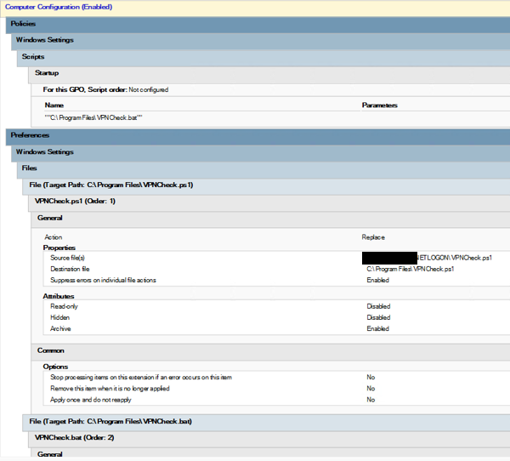
The powershell has a loop, each loop it does the following
- Check if on domain network
- If not then check if VPN exists
- Create VPN if needed
- Dial VPN
- Wait 15 seconds then loop
The powershell has more comments on how it does this.

